

How to Configure DTRANSFER & VDO with SSL

Release History

Author: Amar Kargutkar

Date Created: August 17, 2017



**Copyright Notice**

This document (written or otherwise displayed on magnetic media or other medium) contains confidential and proprietary information of The ALT Digital Media Entertainment Limited or its affiliates.

It has been furnished only for informational purposes, and no license or permission is hereby granted to use such information in any manner. In no event may this information be reproduced, distributed and/or publicly displayed in any form or by any means without prior expressed written permission of The ALT Digital Media Entertainment Limited or its affiliates. All rights reserved.

**Pre-requisite:**

* Ubuntu 14.04 LTS
* Apache, PHP, MYSQL

**Steps to configure Dtransfer & Vdo:**

1. Press ctrl+alt+T for terminal and Login as root user

sudo su

Then enter your root user’s password

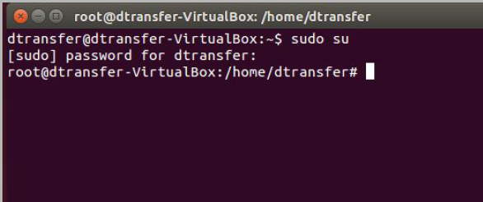

1. Update repository

sudo apt-get update

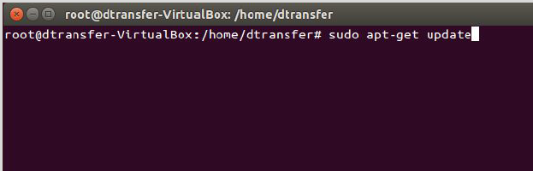

1. Install Apache

sudo apt-get install apache2

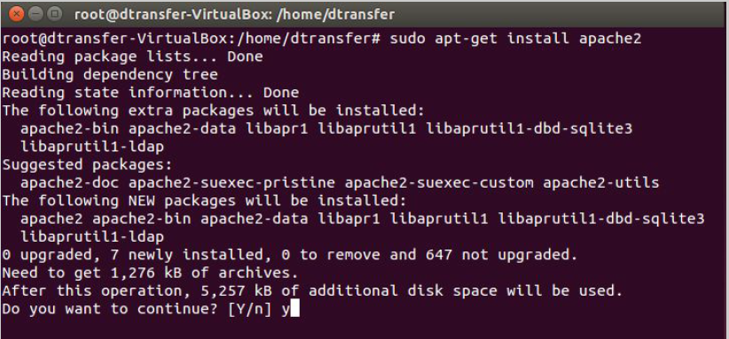

1. Install Mysql

sudo apt-get install mysql-server libapache2-mod-auth-mysql php5-mysql

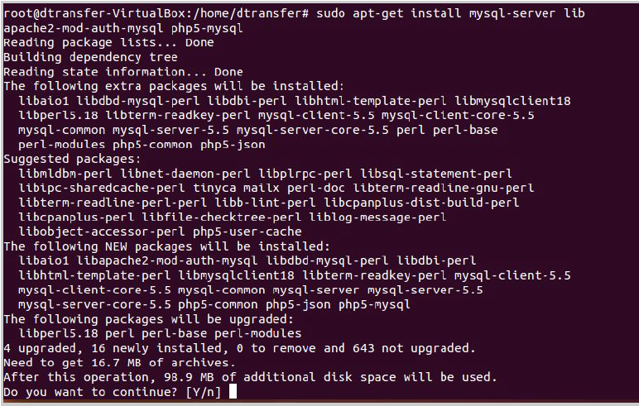

During the installation, MySQL will ask you to set a root password. If you miss the

chance to set the password while the program is installing, it is very easy to set the

password later from within the MySQL shell

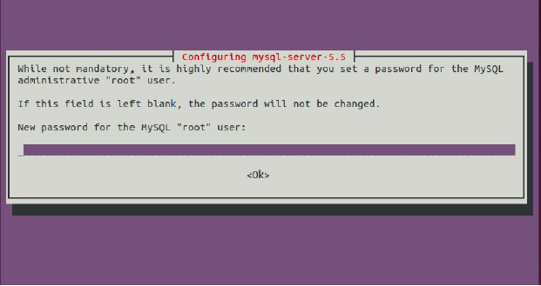

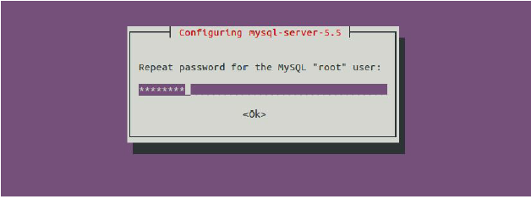

Once you have installed MySQL, we should activate it with this command:

sudo mysql_install_db



Then this command:

sudo /usr/bin/mysql_secure_installation



The prompt will ask you for your current root password.

Type it in.

Enter current password for root (enter for none):

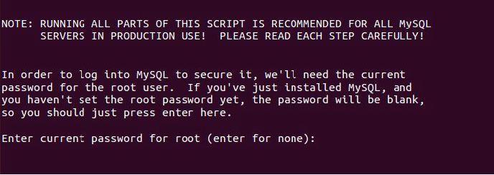

OK, successfully used password, moving on...

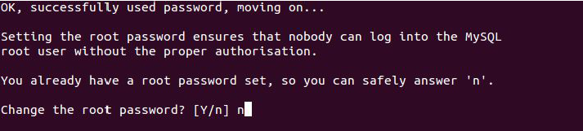

Then the prompt will ask you if you want to change the root password. Go ahead and choose N and move on to the next steps. It’s easiest just to say Yes to all the options. At the end, MySQL will reload and implement the new changes. By default, a MySQL installation has an anonymous user, allowing anyone to log into MySQL without having to have a user account created for them. This is intended only for testing, and to make the installation go a bit smoother. You should remove them before moving into a production environment.

Remove anonymous users? [Y/n] y

... Success!

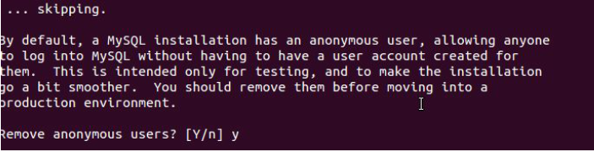

Normally, root should only be allowed to connect from 'localhost'. This ensures that someone cannot guess at the root password from the network.

Disallow root login remotely? [Y/n] y

... Success!

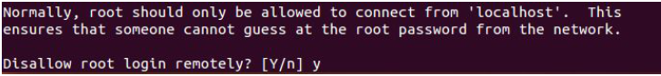

By default, MySQL comes with a database named 'test' that anyone can access. This is also intended only for testing, and should be removed before moving into a production environment.

Remove test database and access to it? [Y/n] y

- Dropping test database...

... Success!

- Removing privileges on test database...

... Success!

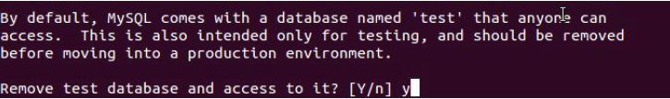

Reloading the privilege tables will ensure that all changes made so far will take effect immediately.

Reload privilege tables now? [Y/n] y

... Success!

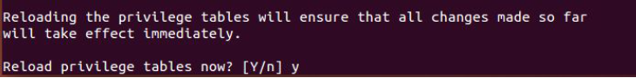

Cleaning up...

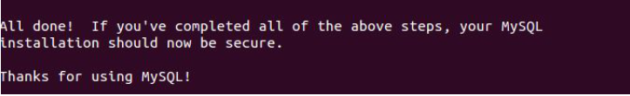

Once you're done with that you can finish up by installing PHP.

1. Install PHP

sudo apt-get install php5 libapache2-mod-php5 php5-mcrypt

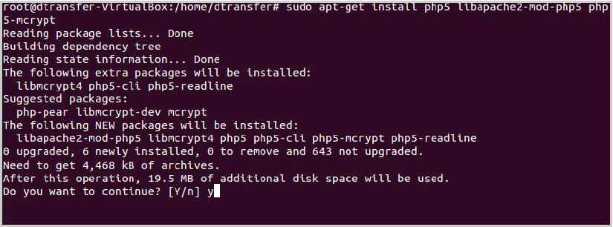

1. Restart Apache

sudo service apache2 restart**

1. Install SSH(Enable port 22)  
   *sudo apt-get install openssh-server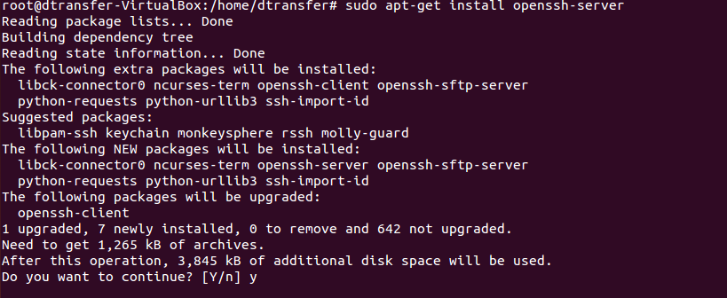 sudo ufw allow 22* *sudo service apache2 restart*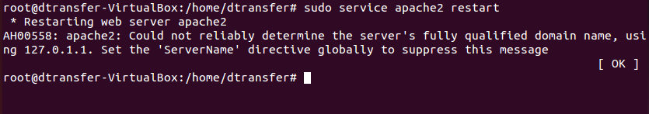
2. Enable URL Rewrites   
   *sudo a2enmod rewrite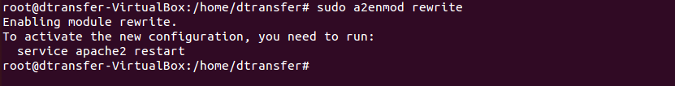 sudo service apache2 restart*  
   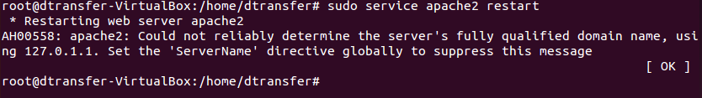

*sudo gedit /etc/apache2/sites-enabled/000-default.conf*

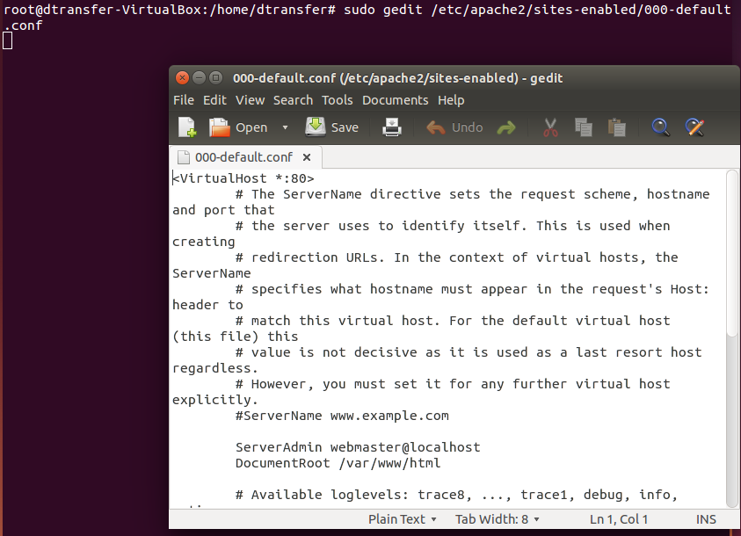

Inside that file, you will find the <VirtualHost *:80> block on line 1. Inside of that block, add the following block:

/etc/apache2/sites-available/default

<Directory /var/www/html>  
 Options Indexes FollowSymLinks MultiViews  
 AllowOverride All  
 Order allow,deny  
 allow from all  
</Directory>

Your file should now match the following. Make sure that all blocks are properly indented.

/etc/apache2/sites-available/default

<VirtualHost *:80>  
 <Directory /var/www/html>  
 . . .

</Directory>  
  
 . . .  
</VirtualHost>  
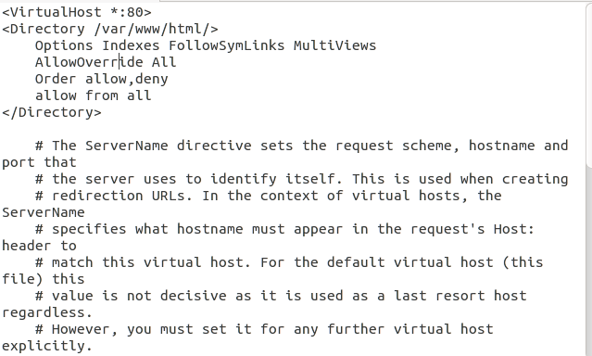

To put these changes into effect, restart Apache.

*sudo service apache2 restart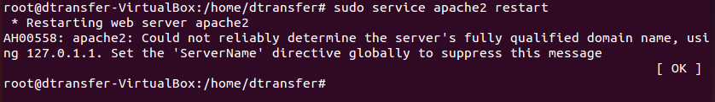*

1. Enhance default values  
   *sudo gedit /etc/php5/apache2/php.ini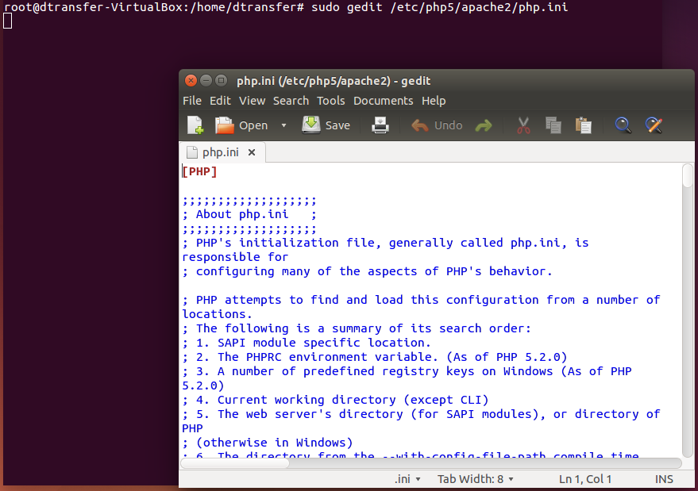*

Find the below variables and change it

Default:

post_max_size = 8M (Line 693)  
 upload_max_filesize = 2M (Line 805)

memory_limit = 128M (Line 406)

max_execution_time = 30 (Line 385)

Update to:

post_max_size = 800M

upload_max_filesize = 2000M

memory_limit = 512M

max_execution_time = 300

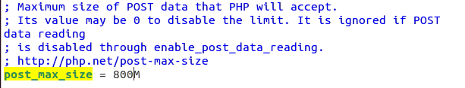

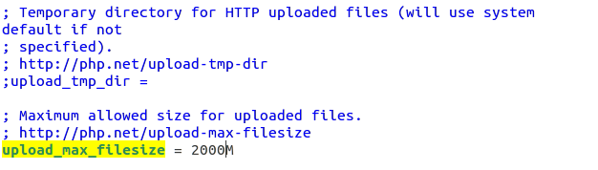

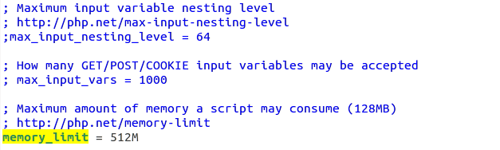

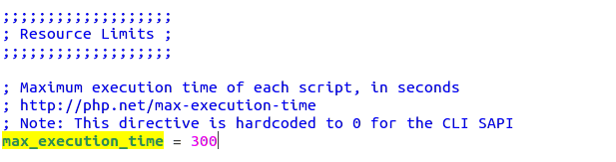

Save file and then execute

*sudo service apache2 restart*

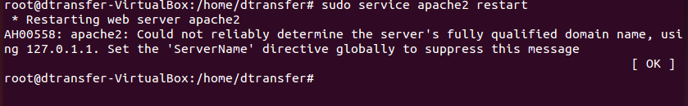

1. Install phpmyadmin  
   *sudo apt-get install phpmyadmin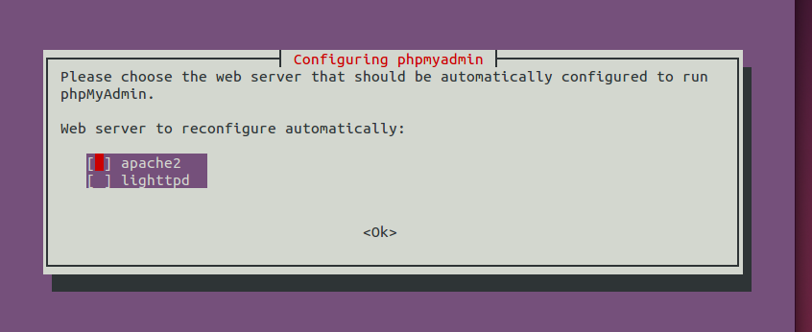*Select the apache by clicking space. It is selection necessary after selection it will contain a start please confirm twice that its selected.  
   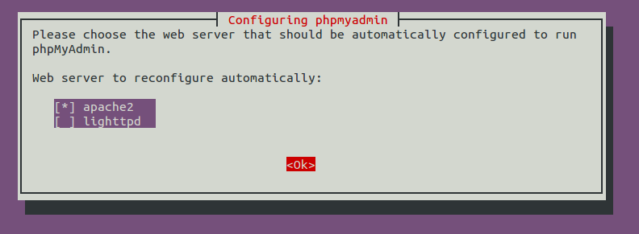  
   Select Yes  
   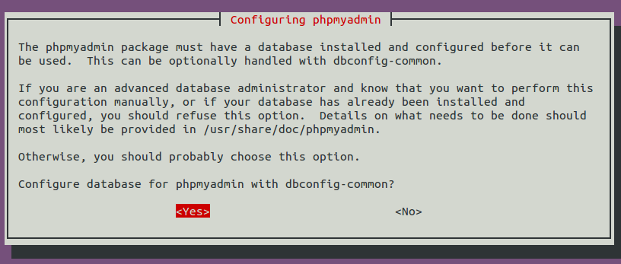  
   Enter password you used while installing MySql  
   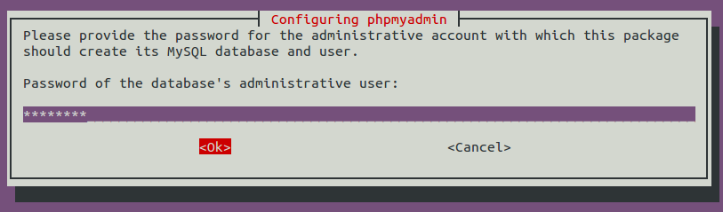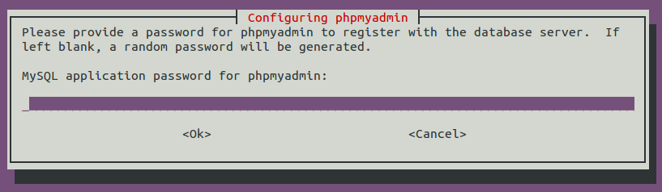
2. Setting permissions  
   *sudo chmod 777 -R /var/www/html*
3. Create a directory inside /var/www/html/ with any name, Which is referred as foldername and eg used in images is vdo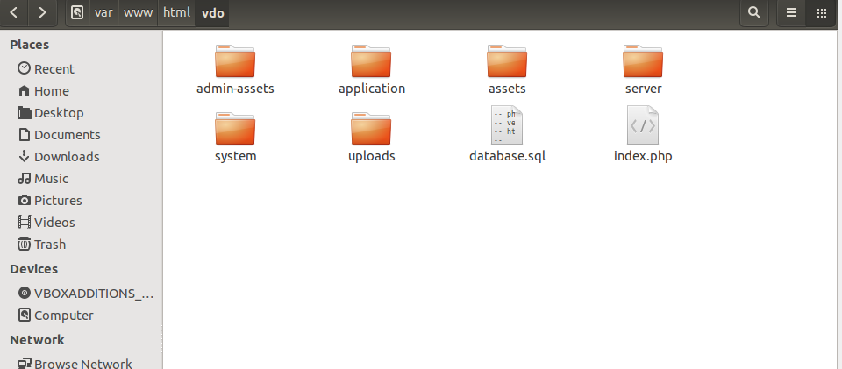
4. Install LDAP *sudo apt-get install php5-ldap  
   sudo service apache2 restart*
5. Place the zip into */var/www/html/dtransfer/* and extract into root of html directory  
   *sudo chmod 777 -R /var/www/html/dtransfer/application/logs  
   sudo chmod 777 -R /var/www/html/dtransfer/uploads  
   sudo chmod 777 -R /var/www/html/dtransfer/server/php/files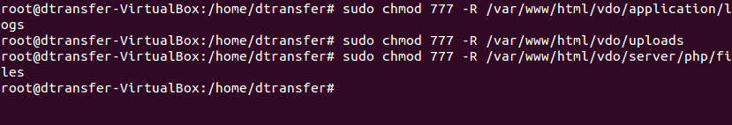*
6. Setting up database   
   Open Browsers visit *http://yourlocalip/phpmyadmin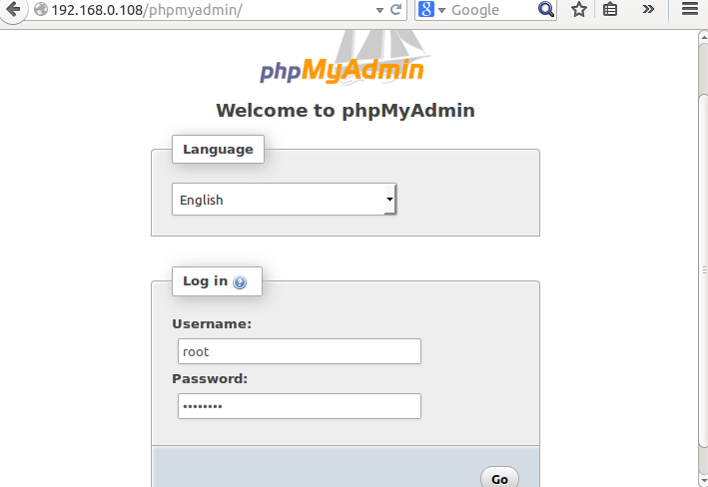*Enter username as root and password you set during MySql installation  
   Click on database then enter database name and create, here referred as dtransfer.  
   Importing Database  
   Select database name form right->import->select file(database.sql from vdo folder)->go  
   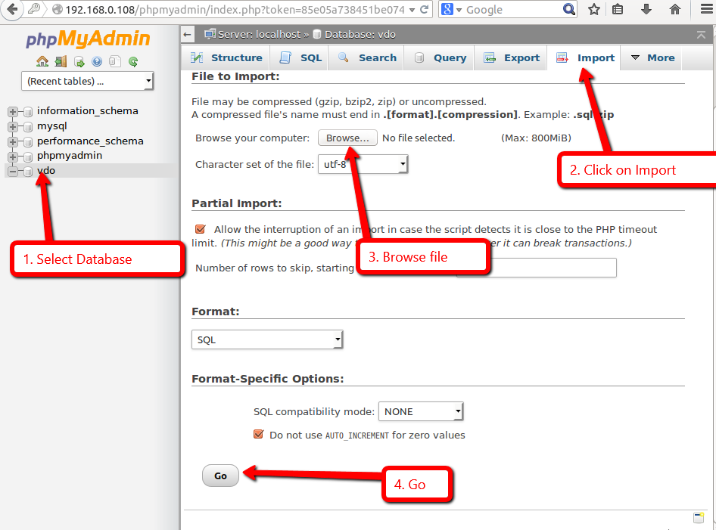
7. Updating the database config file  
   *sudo gedit /var/www/html/dtransfer/application/config/database.php  
   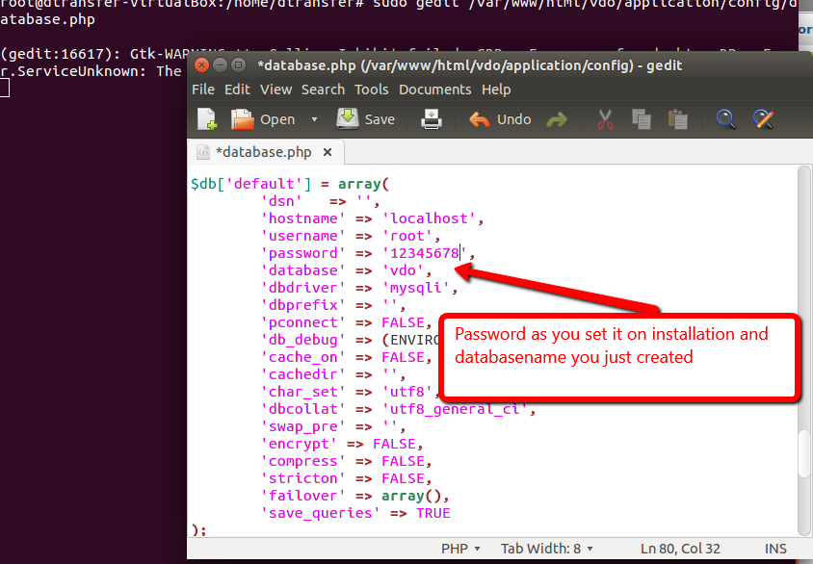*

Change the password you set while installing MySql on line 80, save and exit.

1. Create a file name .htaccess and add following code

sudo gedit */var/www/html/dtransfer/.htaccess*  
*Options -Indexes*

*RewriteEngine On*

*RewriteCond %{REQUEST_FILENAME} !-f*

*RewriteCond %{REQUEST_FILENAME} !-d*

*RewriteRule ^(.*)$ index.php/$1 [L]  
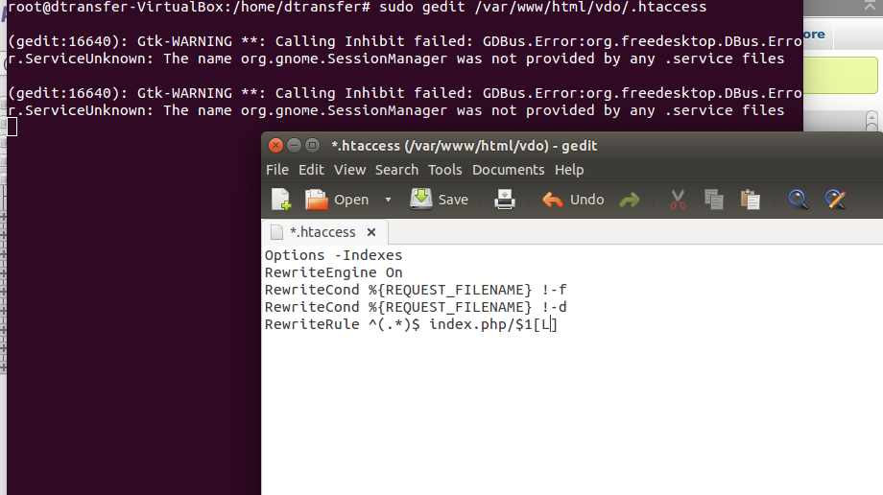*

Save and exit.

1. Setup is done you will be able to see the installation in your browser by <http://yourlocalip/dtransfer>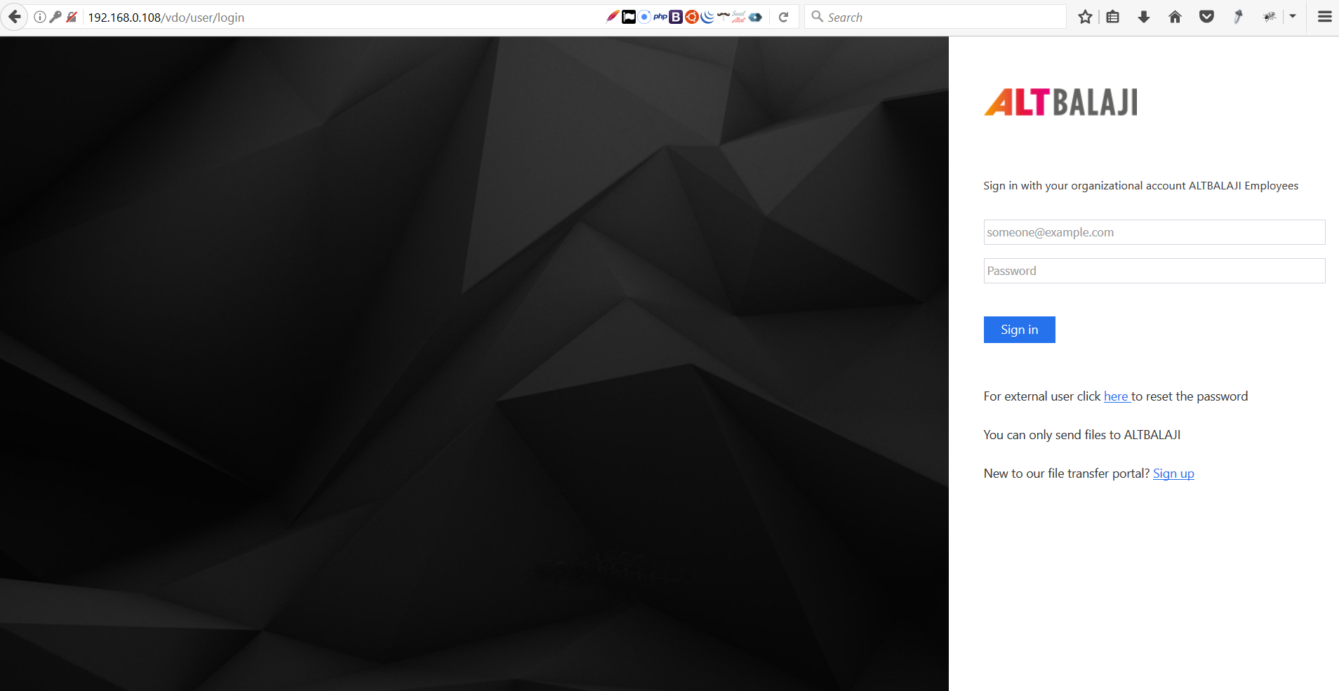
2. We will now setup easy host names for public  
   *sudo gedit /etc/apache2/sites-enabled/000-default.conf  
   <VirtualHost *:80>  
    ServerAdmin admin@example.com  
    ServerName hostname  
    ServerAlias hostname  
    DocumentRoot /var/www/html/foldername*<Directory /var/www/html/foldername>  
    Options Indexes FollowSymLinks MultiViews  
    AllowOverride All  
    Order allow,deny  
    allow from all  
   </Directory>  
    *</VirtualHost>*Hostname is the domain name you want to assign and completed setup in your domain account pointing it to machine in eg. we used vdo.altbalaji.in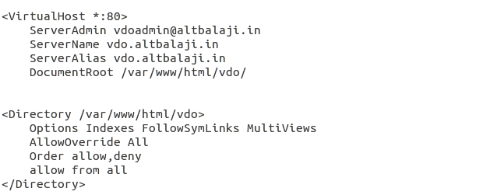
3. Setting up cron jobs  
   *chmod +x /var/www/html/dtransfer/cron.php  
   crontab -e*  
   Add this to file and save.  
   *0,30 * * * * /usr/local/bin/php /var/www/html/cron.php*
4. Place the zip into */var/www/html/vdo/* and extract into root of html directory  
   *sudo chmod 777 -R /var/www/html/vdo/application/logs  
   sudo chmod 777 -R /var/www/html/vdo/uploads  
   sudo chmod 777 -R /var/www/html/vdo/server/php/files*
5. Setting up database   
   Open Browsers visit *http://yourlocalip/phpmyadmin*Enter username as root and password you set during MySql installation  
   Click on database then enter database name and create, here referred as vdo.  
   Importing Database  
   Select database name form right->import->select file(database.sql from vdo folder)->go  
   
6. Updating the database config file  
   *sudo gedit /var/www/html/vdo/application/config/database.php  
   *

Change the password you set while installing MySql on line 80, save and exit.

1. Create a file name .htaccess and add following code

sudo gedit */var/www/html/vdo/.htaccess*  
*Options -Indexes*

*RewriteEngine On*

*RewriteCond %{REQUEST_FILENAME} !-f*

*RewriteCond %{REQUEST_FILENAME} !-d*

*RewriteRule ^(.*)$ index.php/$1 [L]  
*

Save and exit.

1. Setup is done you will be able to see the installation in your browser by <http://yourlocalip/vdo>
2. We will now setup easy host names for public  
   *sudo gedit /etc/apache2/sites-enabled/000-default.conf  
   <VirtualHost *:80>  
    ServerAdmin admin@example.com  
    ServerName hostname  
    ServerAlias hostname  
    DocumentRoot /var/www/html/foldername*<Directory /var/www/html/foldername>  
    Options Indexes FollowSymLinks MultiViews  
    AllowOverride All  
    Order allow,deny  
    allow from all  
   </Directory>  
    *</VirtualHost>*Hostname is the domain name you want to assign and completed setup in your domain account pointing it to machine in eg. we used vdo.altbalaji.in

**Steps to configure SSL for Dtransfer & Vdo:**

1. Enable SSL

sudo a2enmod ssl

sudo service apache2 restart

1. Edit SSL File

sudo gedit/etc/apache2/sites-available/default-ssl.conf

<IfModule mod_ssl.c>  
<VirtualHost _default_:443>  
ServerAdmin admin@example.com  
ServerName your_domain.com  
ServerAlias www.your_domain.com  
DocumentRoot /var/www/html  
ErrorLog ${APACHE_LOG_DIR}/error.log  
CustomLog ${APACHE_LOG_DIR}/access.log combined  
SSLEngine on  
SSLCertificateFile /etc/apache2/ssl/apache.crt  
SSLCertificateKeyFile /etc/apache2/ssl/apache.key  
<FilesMatch "\.(cgi|shtml|phtml|php)$">  
SSLOptions +StdEnvVars  
</FilesMatch>

<Directory /var/www/html/foldername>  
Options Indexes FollowSymLinks MultiViews  
AllowOverride All  
Order allow,deny  
allow from all  
</Directory>  
  
<Directory /usr/lib/cgi-bin>  
SSLOptions +StdEnvVars  
</Directory>  
BrowserMatch "MSIE [2-6]" \  
nokeepalive ssl-unclean-shutdown \  
downgrade-1.0 force-response-1.0  
BrowserMatch "MSIE [17-9]" ssl-unclean-shutdown  
</VirtualHost>  
</IfModule>

1. Place your certificate files to correct path and add it in above code accordingly and change your foldername with the path of installation.
2. Activate SSL File

sudo a2ensite default-ssl.conf

sudo service apache2 restart

1. You can now test to visit via https.
2. Additional Settings

Please visit foldername>application/config/config.php change base_url to your domain name include https eg. $config['base_url'] = 'https://drophere.altdigital.in';

1. Forcing for https only

Visit foldername>.htaccess file add following code at the end

RewriteCond %{SERVER_PORT} 80   
RewriteRule ^(.*)$ https://www.example.com/$1 [R,L]

Replace example.com with your domain eg. https://drophere.altdigital.in